**Quiz 4** [redo]

Brooklyn College Squirrel Database Utilizing MariaDB

**Group Members:**

Edward Lee

Jonathan Yashayev

Peter Wong

Ramy Ghoneim

Swann Thantsin

Tahir Mammadli

**CISC 3140 MW2**

Fall 2022

2900 Bedford Ave, Brooklyn, NY, 11210

CUNY Brooklyn College

**Table of Contents**

Cover Page…………….……………….…………………………………………...1

Table of Contents…………………………………..……………………………….2

Abstract……………………………………………..………………………………3

Schedule……………….…………………………………...……………...………..3

Responsibilities…………….………………………………..……………………...3

OS Systems & Database Software Details………………………….……………...4

Data Dictionary & ERD…….................................................................................5-6

Example SQL Scripts……………..……………………………………………...7-8

**Abstract**

Work in a team utilizing MariaDB to create a functional database that would enable users to track data regarding squirrels on Brooklyn College’s campus. This database will track data regarding squirrel appearance, location, and date/time.

**Schedule:**

*November 18*: Agreed on redo with professor.

*November 21*: Submitted MariaDB as database of choice.

*November 22*: Held a meeting regarding the installation and usage of MariaDB.

*November 24*: Held a meeting regarding the structure of the database and constructed a schema.

*November 26*: Created the tables in MariaDB.

*November 26*: All members of the group tested the database using SQL Shell.

*November 27*: Completed the final revisions on report.

**Responsibilities:**

We loosely divided up the tasks for each person. Some people helped out others on their portions and reviewed in case anyone needed help. Below is a rough outline of the main tasks. Communicated over Discord and WhatsApp, utilized those tools to plan our work schedules and contributions.

* **Edward Lee**: Formatted the project report.
* **Jonathan Yashayev**: Wrote the data dictionary and CRUD script.
* **Peter Wong**: Constructed an ERD and outline for database.
* **Ramy Ghoneim**: Researched advantages of MariaDB and worked on outline.
* **Swann Thantsin**: Assisted picking a new database system and worked on CRUD.
* **Tahir Mammadli**: Created the database on MariaDB and worked on formatting report.

**Description of Database Product:**

1. **MariaDB.**
2. **Version:**

* *10..10.2 -* MariaDB Windows 10.

1. **Group Member Operating Systems & Installation Instructions.**

* Edward Lee: Windows 10 & MacOS.
* Jonathan Yashayev: Windows 10 & MacOS Monterey 12.1.
* Peter Wong: Windows 10.
* Ramy Ghoneim: MacOS.
* Swan Thantsin: Windows 10.
* Tahir Mammadli: Linux PopOS.

**Installation Instructions:**

* Go to <https://mariadb.org/download/?t=mariadb>, select your version, current LTS is 10.10.2, select your OS (Windows, Source, Linux), select architecture, (x86_64), and select your package type (MSI Package.) There is an option to download as a .zip file as well. Select mirror download (I used osuosl.)

1. **Documentation & Tutorial:**

* Documentation:  <https://mariadb.org/documentation/>
* Tutorial:  <https://mariadb.com/kb/en/beginner-mariadb-articles/>

1. **Advantages of Our Database:**

Three main reasons to pick Maria DB over others. Performance - it is better suited for smaller databases (such as a class project), and is more lightweight than its counterparts allowing people with lower-end machines to have a better user experience. Data types - implementation of data types is more forgiving than PostgreSQL considering it’s not strictly typed and comes with an auto-correct mechanism. Large companies such as Walgreens and Korean tech giant Samsung use MariaDB as their main database management system.

**Data Organization**

1. **Data Dictionary:**

**Squirrel_Sighting**

|  |  |  |  |  |  |  |
| --- | --- | --- | --- | --- | --- | --- |
| Field Name | Data Type | Data Format | Field Size | Description | Example | Req? |
| squirrel_sighting_id | int | 000000 | 6 | ID number for each sighting | 000004 | Y |
| color_key | varchar | Text | 10 | Combination of primary & secondary as key | GrBr | Y |
| activity | varchar | Text | 30 | What squirrel is doing at the moment of data collection | Climbing | Y |
| age | varchar | Text | 30 | Age based on appearance | Juvenile | Y |
| date | date | YYYY-MM-DD | 30 | Date at data collection | 2022-11-11 | Y |
| time | time | H:M:SEC.MS | 30 | Time at data collection | 10:47:20.95921 | Y |
| location_id | int | 000000 | 6 | ID of location | 000001 | Y |

**Location**

|  |  |  |  |  |  |  |
| --- | --- | --- | --- | --- | --- | --- |
| Field Name | Data Type | Data Format | Field Size | Description | Example | Req? |
| location_id | int | 000000 | 6 | ID number for each location | 000003 | Y |
| longitude | real | 90.0000 | 20 | Longitude of sighting | 71.6422 | Y |
| latitude | real | 180.0000 | 20 | Latitude of sighting | 27.2399 | Y |
| quad | varchar | Text | 10 | What quad data is collected in | West | Y |

**Appearance**

|  |  |  |  |  |  |  |
| --- | --- | --- | --- | --- | --- | --- |
| Field Name | Data Type | Data Format | Field Size | Description | Example | Req? |
| color_key | varchar | Text | 10 | Color key for squirrel color combos | BrOr | Y |
| primary_color | varchar | Text | 10 | Primary color of squirrel | Brown | Y |
| secondary_color | varchar | Text | 10 | Secondary color of squirrel | Orange | N |

1. **Entity Relational Diagram:**

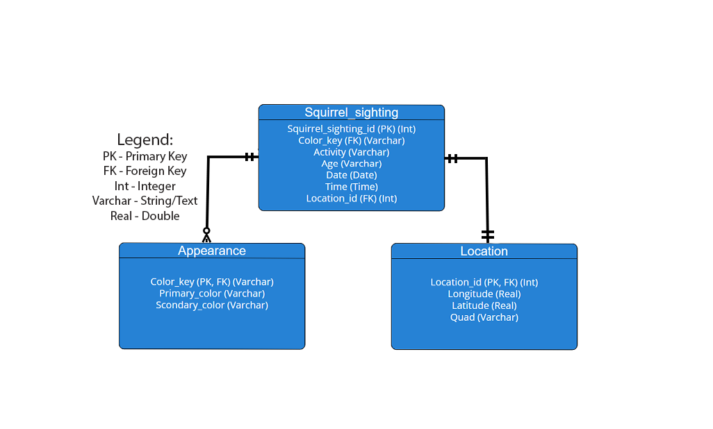

**Example SQL Scripts (CRUD)**

**Squirrel_Sighting Table**

This database supports inserting new squirrel sightings, which is needed when researchers document details of their squirrel sighting. Includes two foreign keys for the location and squirrel appearance to make the database less redundant and easier to maintain for future researchers.

It is mandatory that all values are filled, denoted by the “NOT NULL” keyword during variable creation in SQL. The upper case words denote SQL syntax, while lowercase are user input values.

* INSERT INTO squirrel_sighting VALUES(1, 'BrOr', 'sleeping', 'juvenile', current_date, current_time, 1);
  + Inserts values to every column in squirrel_sighting table [C].
* SELECT * FROM squirrel_sighting;
  + Outputs all (*) values in the squirrel_sighting table [R].
* UPDATE squirrel_sighting SET activity = ‘looking for food’ WHERE activity = ‘sleeping’;
  + Updates the activity value [U].
* DELETE FROM squirrel_sighting WHERE activity = ‘looking for food’;
  + Deletes a record from squirrel_sighting table where the activity is equal to ‘looking for food’ [D].

**Location Table -**

This database supports creating reusable locations to prevent redundancy issues. Four variables to support specificity that's easily referenceable. Include a general location (quad) plus a specific one (lat x long), allowing researchers to reference without having to search coordinates.

It is mandatory that all values are filled, denoted by the “NOT NULL” keyword during variable creation in SQL. The upper case words denote SQL syntax, while lowercase are user input values.

* INSERT INTO location VALUES(1, -73.95613449,40.79408239, ‘west’);
  + Inserts values to every column in the location table [C].
* SELECT * FROM location;
  + Outputs all records in the location table [R].
* UPDATE location SET quad = ‘east’ WHERE quad = ‘west’;
  + Updates the quad from west to east [U].
* DELETE FROM location WHERE activity = ‘east’;
  + Deletes the record where activity is equal to east [D].

**Appearance Table -**

This database supports creating reusable appearances that are specific enough to categorize squirrels into colors based on code requiring at least one value. Color keys must be in the format ‘XxXx,’ The first two letters represent each color. ‘Primary’ and ‘Secondary’ fields will take each color as they are written.

It is possible to have the primary_color be just “Brown” and use the code “Br”. Furthermore, for a squirrel that’s brown and white we’d denote the color_key as “BrWh”.

Secondary color is optional, not required. The upper case words denote SQL syntax, while lowercase are user input values.

* INSERT INTO appearance VALUES(‘BrOr,  'Brown', ‘Orange’);
  + Inserts values into every column in location table [C].
* SELECT * FROM appearance;
  + Outputs all appearance values [R].
* UPDATE appearance SET primary_color = ‘brown’ WHERE primary_color ’gray’;
  + Updates the primary color of a squirrel from brown to gray[U].
* DELETE FROM appearance WHERE primary_color = ‘gray’;
  + Deletes a record where the primary color is gray[D].